**6.3 Project Worksheet: Using Windows System Tools**

|  |  |  |  |
| --- | --- | --- | --- |
| **#** | **Item** | **Tool Used** | **Answer** |
| 1 | OS Version being run | msinfo32 | Microsoft Windows 11 Pro 10.0.22631 Compilación 22631 |
| 2 | Primary Boot Device | diskmgmt.msc | \Device\HarddiskVolume2 |
| 3 | Physical Memory Installed | Task manager | 8.0 GB |
| 4 | Volume Serial Number of Hard Drive | Cmd | 142E-3823 |
| 5 | IP Address of Computer | Cmd | IPv4 address: 192.168.10.2 |
| 6 | Primary DNS Server | ncpa.cpl | DNS: 1.1.1.1 |
| 7 | Memory being used (will change) | Task manager | 7.0 GB |
| 8 | Current user | CMD | DeseretTecnico |
| 9 | Is the Bluetooth User Service currently running? | services.msc | State: Disabled |
| 10 | Is Cortana enabled at startup? | Task manager | State: Disabled |
| 11 | What is the CPU Score using the Windows Experience Index? You may need to research this online. | Cmd  winsat cpu -compression | CPU - Compresión LZW: 509.93 MB/s |
| 12 | When was Windows Update last checked? | Windows Update | Today, 08:57 |
| 13 | Does your PC meet requirements for Windows 11? If running Windows 11 answer Yes! |  | Yes |
| 14 | What is the status of your Firewalls? | Firewall de Windows Defender | Status: Disabled on private and public networks |
| 15 | What is your current theme? | Configuration,themes | Customized |
| 16 | What is your default printer? | Scan y printer | Microsoft Print to PDF |
| 17 | What is the IP address of www.ksl.com | Cmd  nslookup www.ksl.com | 34.144.234.52 |
| 18 | How many hops does it take to get from your computer to www.ensign.edu? | Cmd  tracert www.ensign.edu | 17 hops |
| 19 | How much disk space is currently used for system protection? If system protection is not enabled, you might want to enable it! | sysdm.cpl | 2% |
| 20 | Is remote desktop enabled? | Control panel | yes |

21. Open your Event Viewer and submit a screenshot of the Summary of Administrative Events. Below the screenshot, list the last Error encountered by your PC.

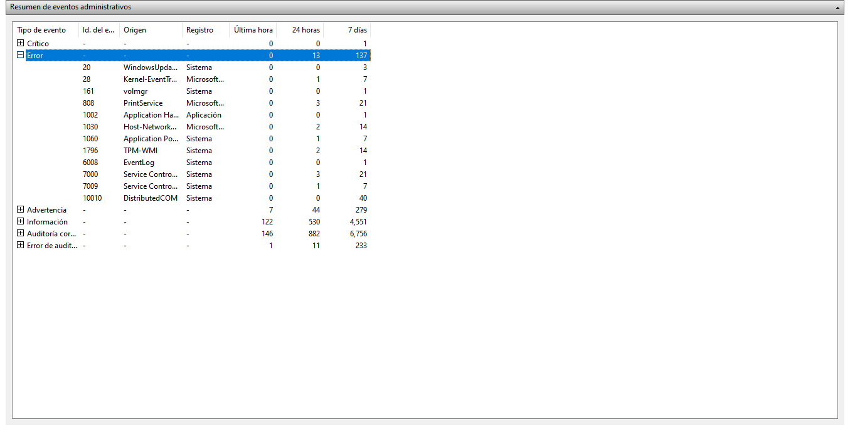

1796

22. You wish to review your computer’s reliability and problem history. Open the appropriate tool and submit a screenshot. Below the screenshot list the last Application failure.

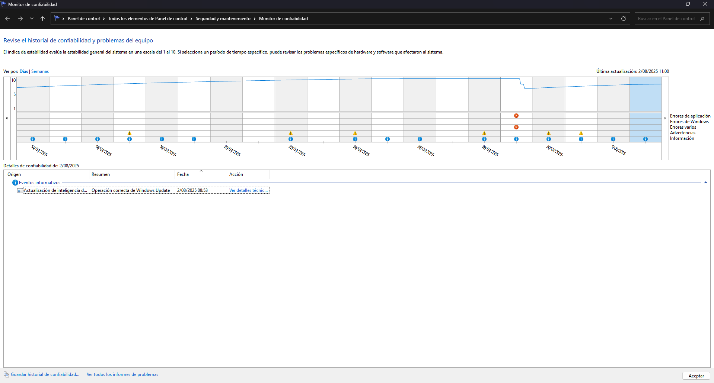

**Descripción**

El programa explorer.exe versión 10.0.22621.5547 dejó de interactuar con Windows y se cerró. Para ver si hay más información disponible sobre este problema, comprueba el historial de problemas en el panel de control de Seguridad y mantenimiento.

23. Open Local Users and Groups using the appropriate tool. Submit a screenshot of the current users on your computer.

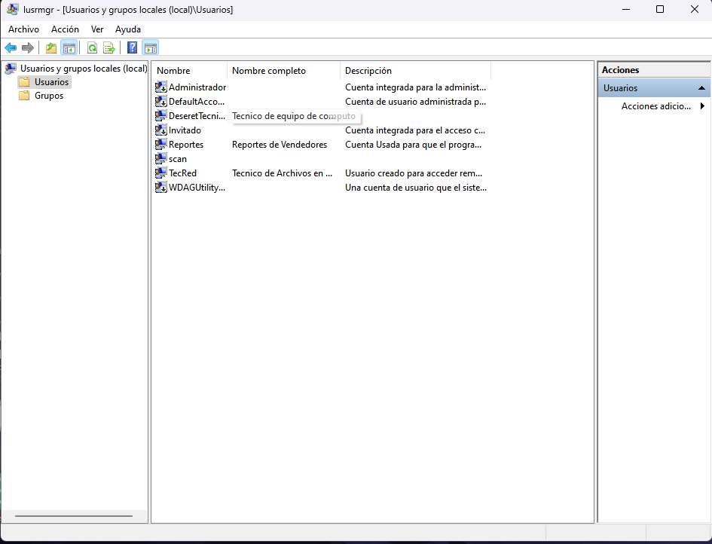

24. You want to view the partitions on your C: drive. Use the appropriate tool and submit a screenshot of the partition data for your drive.

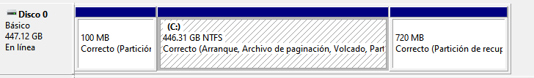

25. You need to find out whether File and Printer Sharing is being blocked by your Firewall. Using the appropriate tool and submit a screenshot showing the status of File and Printer Sharing.

